Eman Furrukh BSDS – U 21I-1726

**COAL LAB ASSIGNMENT #2**

**OUTPUT QUESTIONS**

**Q1)**

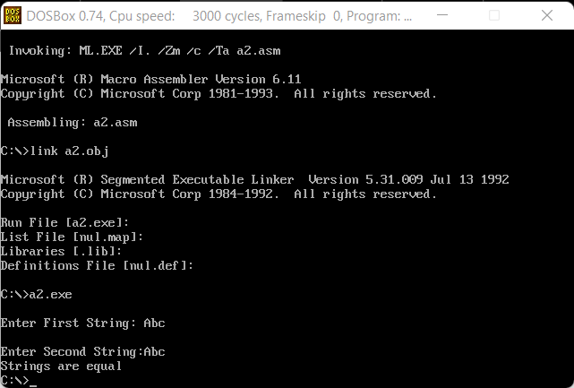**Q2)**

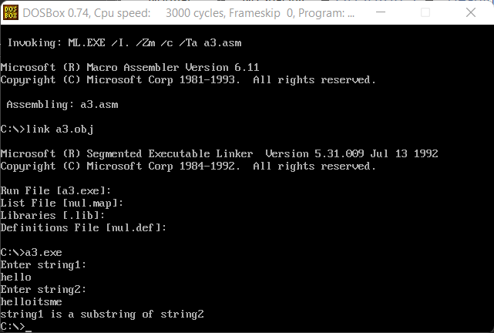**Q3)**